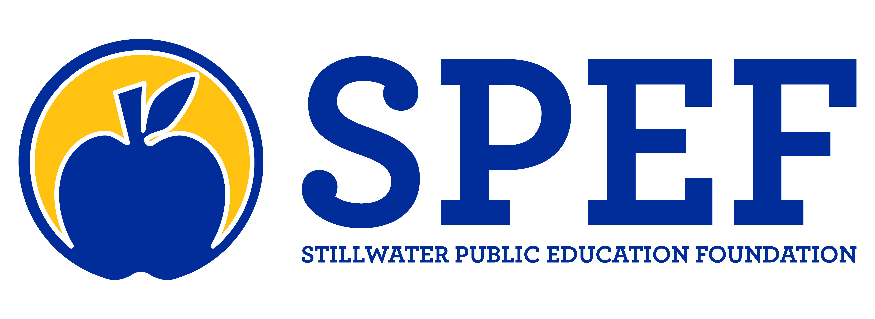

SPEF’s Mission:

Building strong community connections and support for Stillwater Public Schools
Teacher Grant Funding Guidelines 2023-24
Grant Cycles – Small Grants (up to $750) and Large Grants ($751-$4,000)
Thursday, October 20, 2023
Thursday, February 21, 2024

Application Information:
- Small grant requests are funded up to $750
- Large grant requests are funded between $751-$4,000
- Both Small and Large grants requests are accepted during both application periods
- Applications are only accepted from Stillwater Public Schools employees. For an outside individual or group to receive consideration, it must be a collaborative project benefiting our district's students and co-authored and submitted by an SPS teacher, principal or administrator.
- Applicants may receive only one teacher grant award for their classroom per school year.
- Site principal review and approval is required for all grant applications prior to submission.
- Applications for both small and large grants must be submitted via the Google form hyperlinks below:

Small Grants Large Grants
What we are likely to fund:
- Innovative projects/materials/equipment that align with the district’s overall curriculum and approach to learning, including instructional technology tools
- Creative ideas that engage students in the learning process
- Projects that encourage collaboration among multiple SPS sites, across multiple grades or subjects within a school site, among multiple classrooms within a department, etc.
- Professional development/staff development programming (with matching district or site funds and approval)
- Subscriptions for instructional materials (with matching district or site funds and approval)
- Technology detailing a clear & specific instructional plan/purpose (with district IT approval)

*If any District Approval or Matching Funds are required for your grant, the proposal must be reviewed & approved PRIOR to application submission. You will be asked to check “Yes” confirming approval and could be asked to provide documentation at a later date. If documentation cannot be provided upon request, the proposal will not be considered or funded. If any SPEF funds have already been disbursed and documentation of review & approval prior to submission cannot be provided, the grant writer will reimburse SPEF for any and all expenses related to their grant.

What we are unlikely to fund:
- Large scale equipment and furnishings (e.g., playground equipment, classroom furnishings, etc.)
- Desktop/laptop computers, printers and other standard office equipment
- Financial compensation
- Student field trips
- Requests solely from individuals / groups outside of SPS
- General operating fund requests

For questions, please contact:
Ashlee Robertson, SPEF Executive Director – spef@stillwaterschools.com , Ph. (405) 707-5006
Diana Watkins, Chair – SPEF Allocations Committee, diana.watkins@noc.edu , Ph. (580) 628-6905

